SPONSORSHIP FORM
Hoosier State Chapter of the Appraisal Institute
A N N U A L G O L F O U T I N G
Friday August 26th, 2022
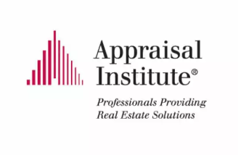
It’s that time of the year again for the annual Hoosier State Chapter of the Appraisal Institute Golf Outing. By popular demand the outing will be again be held at Plum Creek Golf Course in Carmel. We are very thankful to our individuals and companies that help sponsor our event each year. We have several sponsorship opportunities this year, as shown below. If you would like to sponsor this year’s event, please complete and return this form with a check payable to the Hoosier State Chapter of the Appraisal Institute: 9247 N Meridian Street, Suite 325, Indianapolis, IN 46260.
Thank you for your support. Should you have any questions, please feel free to contact either Aaron Wood (aaron.wood@lakecitybank.com), Robert Porterfield (Robert.porterfield@cbre.com), or Shannon O’Keefe (aihoosierstate@sbcglobal.net).
______ Event Sponsor - $1,000 - Includes: Overall event sponsor, 2-person entry, tee sponsor (see below) and recognition at dinner.
______ Gold Sponsor - $500 - Includes: Entry for 2 golfers, tee sponsor (see below) and recognition at dinner.
______ Silver Sponsor - $250 - Includes: Entry for 1 golfer, tee sponsor (see below) and recognition at dinner.
______ Beverage Cart Sponsor - $500 – Includes company logo on beverage cart, entry for 1 golfer and recognition at dinner. Only two (2) sponsorships available.
______ Tee Sponsor - $50 - Includes: Your company name/logo will be posted on a sign in a visible location on one of the tee boxes.
______ Additional Sponsorship: Gift cards, sporting event tickets, electronics, gift baskets, etc…

Sponsorship Name to be displayed: ________________________________________________
(please email your logo to Shannon O’Keefe at aihoosierstate@sbcglobal.net)

